**­­**

**­­­­­­­**

**LAB # 04**

|  |  |
| --- | --- |
| **SUBMITTED TO­** | **­­­Esha E Noor Durrani** |
| **SUBMITTED BY** | **Muhmmad Ayaan Farrukh** |
| **REGISTRATION NO.** | **B24F0488CS035** |

**­**

# **LAB TASK # 01:**

**Write question here.**

Create a simple calculator using switch

**SOURCE CODE:**

|  |
| --- |
| #include<iostream>  using namespace std;  int main(){      char operation;      float num1, num2;      cout <<"Enter an operator (/, +, -, *): ";      cin >> operation;      cout<<"Enter first number: ";      cin>> num1;      cout<<"Enter second number: ";      cin>> num2;      switch(operation){          case '+':          cout << num1 << "+" << num2 << "=" << num1 + num2 << endl;          break;           case '-':          cout << num1 << "-" << num2 << "=" << num1 - num2 << endl;          break;           case '*':          cout << num1 << "*" << num2 << "=" << num1 * num2 << endl;          break;           case '/':           if (num2 != 0){              cout << num1 << "/" << num2 << "=" << num1 / num2 << endl;           }else{              cout<<"Error"<< endl;           }           break;         default:      cout<<"Invalid operation" << endl;       }  } |

**OUTPUT:**

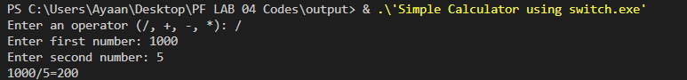

# **LAB TASK # 02:**

­­­­ **Write question here.**

Create a c++ program which gives 5% discount if total is 1-500 and 10% if total is 500-1000.

**SOURCE CODE:**

|  |
| --- |
| #include<iostream>  using namespace std;  int main(){        float discount, price, finalprice;      cout<<"What is the price of the product: ";      cin>>price;      if(price >= 1 && price <= 500){      discount=  0.05;      } else if (price > 500){      discount = 0.10;      } else{          discount=0;      }      finalprice = price - (price * discount);      cout<<"Price of the product= "<< price << endl;      cout<<"Discount= "<< discount << "%" << endl;      cout<<"Price after discount= "<< finalprice << endl;  } |

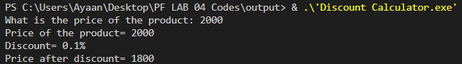**OUTPUT:**